HANOI UNIVERSITY OF SCIENCE AND TECHNOLOGY
SCHOOL OF ELECTRICAL AND ELECTRONIC ENGINEERING


SUB - PROJECT REPORT
KERNEL PANIC VISUALIZER

Name of students: Class code : 161841 – Team 24
Pham Huy Hoang – 20233850
Bui Thai Son – 20233874

Name of instructor: Dr. Pham Van Tien

Hà Nội, 12/2025

Table of Contents
Abstract 1
I - GENERAL & ADMINISTRATIVE INFORMATION 2
1. Project overview 2
2. Team Members & Contribution 2
3. Project Timeline & Milestones 3
4. Development Resources 3
5. Key Achievements 3
II - THEORETICAL BACKGROUND & SYSTEM ARCHITECTURE 4
2.1. Kernel Panic in Operating Systems 4
2.2. Panic Data Flow 4
2.3. System Components 4
III – TECHNICAL IMPLEMENTATION 5
3.1. Panic Visualization and Reboot Logic (printf.c) 5
3.2. Intentional Kernel Panic System Call (sysproc.c) 8
3.3. Automatic Reboot Wrapper (Makefile) 8
3.4. Design Rationale 9
IV – EXPERIMENTAL RESULTS & EVALUATION 10
4.1. System Boot Sequence 10
4.2. Intentional Kernel Panic Trigger 11
4.3. Hardware Trap Information 11
4.4. Colorized Kernel Panic Visualizer Output 11
4.5. System Halt and Emulator Termination 12
4.6. Automatic Reboot via External Wrapper 12
4.7. Successful System Reboot 13
4.8. Summary of Observations 13
V – CONCLUSION 14
5.1. Conclusion 14
5.2. System Limitations 14
5.3. Lessons Learned 14
5.4. Future Development 15
5.5. Final Remarks 15
Appendix A – Detailed Implementation of the kpanic System Call 16
REFERENCES 20

Abstract
Kernel panics represent critical failure states in operating systems, often providing limited diagnostic information and requiring manual intervention for recovery. In educational operating systems such as xv6-riscv, the default panic mechanism outputs minimal text-based logs and halts the system, making debugging difficult and repetitive testing inefficient.
This project presents the design and implementation of a Kernel Panic Visualizer with an Automatic Reboot Mechanism for xv6-riscv. The proposed system enhances the standard panic output by introducing structured, color-coded diagnostic information, including panic reasons, decoded CPU exception states (sepc, scause), and process context details. These enhancements significantly improve log readability and reduce debugging time without introducing graphical overhead.
In addition, an automatic reboot mechanism is implemented using a kernel-triggered QEMU termination combined with an external Makefile wrapper. This approach enables reliable system recovery after fatal kernel errors while avoiding unsafe in-kernel reboot logic.
The system is evaluated using a controlled kernel panic test (kpanic) that intentionally triggers a NULL pointer access in kernel space. Experimental results demonstrate that the panic visualizer correctly captures and presents diagnostic information and that the automatic reboot mechanism consistently restores system execution without manual restart commands.
Overall, the project demonstrates a practical and extensible approach to improving kernel panic diagnostics and recovery in a minimalist operating system environment.

I - GENERAL & ADMINISTRATIVE INFORMATION

Project overview
Objective:
Enhance the default kernel panic mechanism by:
- Providing color-coded panic visualization for better debugging.
- Capturing detailed hardware and process states at crash time.
- Implementing a stable automatic reboot mechanism for testing and development.
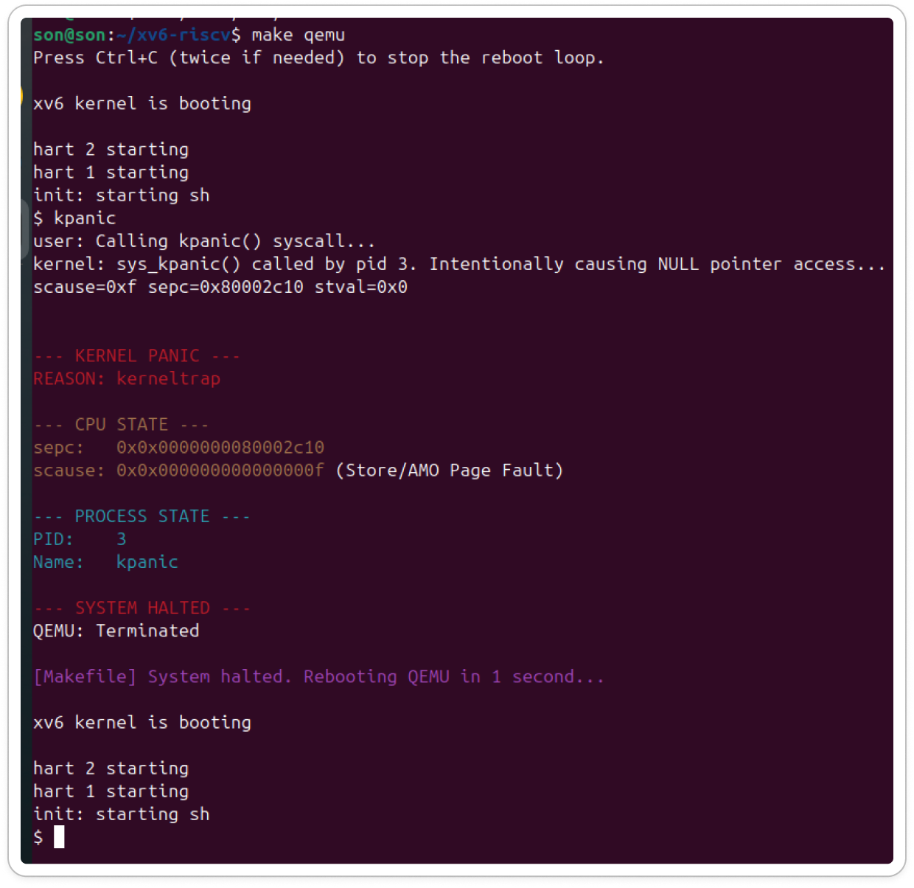
- Team Members & Contribution
No | Full Name | Student ID | Role | Main Contributions | Contribution
1 | Bùi Thái Sơn | 20233874 | Lead Developer & Researcher | - Designed and implemented parser.py  - Panic log saving logic  - Research & implementation of external auto-reboot wrapper | 50%
2 | Phạm Huy Hoàng | 20233850 | System Engineer & UI/UX | - Refactored kernel panic() in printf.c  - Integrated ANSI color visualization  - CPU register extraction (sepc, scause)  - Stability testing | 50%

3. Project Timeline & Milestones
- Total progress reports: 05
Week | Activities
Week 1–2 | Research kernel panic mechanism, build basic panic log parser
Week 3 | Integrate visualizer into kernel using ANSI colors
Week 4 | Investigate and debug failed auto-reboot approaches
Week 5 | Implement countdown-based reboot trigger & finalize project

4. Development Resources
- Design (Figma): https://www.figma.com/board/J5MbGJ5XB0r9fjJr3cjv3c/Untitled?node-id=0-1&t=OapC3PagWbS8Ru5q-1
- Task Management (Jira): https://son-hoang.atlassian.net/jira/core/projects/KPV/list?jql=project+%3D+KPV+ORDER+BY+created+DESC&atlOrigin=eyJpIjoiZDc4MjZkMTVhMWQ1NGNiMDkxZWMyNWJmNzQ4NWVlY2QiLCJwIjoiaiJ9
- Source Code Repository: https://github.com/hoang1015/xv6-riscv

5. Key Achievements
- Colorized Kernel Panic Visualizer (100% complete)
- Decoded Hardware & Process State Logging
- Stable Automatic Reboot Mechanism via QEMU wrapper

II - THEORETICAL BACKGROUND & SYSTEM ARCHITECTURE

Kernel Panic in Operating Systems
A Kernel Panic occurs when the operating system detects a fatal internal error that compromises system safety, such as:
- Illegal memory access
- Page faults
- Hardware exceptions
At this point, the kernel must halt or reboot to prevent further damage.

Panic Data Flow
When a critical failure occurs:
- CPU triggers an exception
- Trap handler captures the event
- Kernel invokes panic()
- Hardware registers (sepc, scause) are read
- Diagnostic information is printed
- System halts or reboots

System Components
- kernel/printf.c
  - Core module modified
  - panic() function rewritten
  - Added color formatting & reboot logic
- main.c
  - Contains test routines (e.g., kpanic)
  - Used to intentionally trigger kernel faults

III – TECHNICAL IMPLEMENTATION
Code-Level Explanation of System Modifications
This section explains the key source code modifications that enable the Kernel Panic Visualizer and the Automatic Reboot Mechanism.

3.1. Panic Visualization and Reboot Logic (printf.c)
a) ANSI Color Definitions
#define RED "\x1b[31m"
#define YELLOW "\x1b[33m"
#define CYAN "\x1b[36m"
#define MAGENTA "\x1b[35m"
#define RESET "\x1b[0m"
These macros define ANSI escape color codes used directly by the kernel’s printf() function.
Their purpose is to improve panic log readability by visually separating different diagnostic sections (error messages, CPU state, process state, and reboot status) without introducing any graphical interface or performance overhead.

b) QEMU Test Device Control
#define QEMU_TEST_CTRL (volatile uint32*)(0x100000)
#define QEMU_TEST_FAIL 0x3333
- QEMU_TEST_CTRL is a special memory-mapped I/O (MMIO) address provided by QEMU for testing.
- Writing the value QEMU_TEST_FAIL to this address immediately terminates the QEMU instance.
This mechanism is used as a controlled termination trigger, allowing an external wrapper to detect kernel failure and restart the system.

c) Busy-Wait Delay Function
void
panic_spin_delay(uint64 count)
{
volatile uint64 i;
for(i = 0; i < count; i++)
;
}
This function implements a busy-wait delay.
Key characteristics:
- Does not rely on timer interrupts
- Safe to use after the system has entered a panic state
- Delay duration depends on the host CPU speed
It is used to implement a visible countdown before rebooting.

d) Rewritten panic() Function
The panic() function was fully rewritten to extend diagnostic capabilities and integrate automatic reboot logic.
• System State Collection
uint64 sepc = r_sepc();
uint64 scause = r_scause();
struct proc *p = myproc();
- sepc: Program Counter at the time of the exception
- scause: Cause of the trap, as defined by the RISC-V specification
- p: Pointer to the currently running process, if available
• Colorized Kernel Panic Output
printf(RED "\n\n--- KERNEL PANIC ---\n" RESET);
printf(RED "REASON: %s\n\n" RESET, s);
The panic header and reason are printed in red to clearly indicate a fatal kernel error.

• CPU State Display and Exception Decoding
printf(YELLOW "sepc: 0x%p\n" RESET, (void*)sepc);
printf(YELLOW "scause: 0x%p" RESET, (void*)scause);
The trap cause (scause) is manually decoded:
if(scause == 12) printf(" (Instruction Page Fault)\n");
else if(scause == 13) printf(" (Load Page Fault)\n");
else if(scause == 15) printf(" (Store/AMO Page Fault)\n");
This decoding allows developers to immediately understand the nature of the fault without consulting external documentation.
• Process State Visualization
if(p) {
printf(CYAN "PID: %d\n" RESET, p->pid);
printf(CYAN "Name: %s\n" RESET, p->name);
}
If a panic occurs within a process context, the system prints:
- Process ID (PID)
- Process name
If no process context exists, the kernel explicitly reports this condition.
• Automatic Reboot Countdown
printf(MAGENTA "\nAuto-rebooting system in 3 seconds...\n" RESET);
for(int i = 3; i > 0; i--){
printf(MAGENTA "%d...\n" RESET, i);
panic_spin_delay(200000000);
}
A visible 3–2–1 countdown is displayed before rebooting, allowing sufficient time to review the panic log.
The magenta color distinguishes reboot messages from error diagnostics.
• QEMU Exit Trigger
*QEMU_TEST_CTRL = QEMU_TEST_FAIL;
Writing to the QEMU test control register terminates the emulator.
After triggering the exit, the kernel enters an infinite loop to prevent further execution:
for(;;)
;

3.2. Intentional Kernel Panic System Call (sysproc.c)
uint64
sys_kpanic(void)
{
printf("kernel: sys_kpanic() called by pid %d. Intentionally causing NULL pointer access...\n", myproc()->pid);
*(volatile int *)0 = 42;
return 0;
}
The sys_kpanic() system call is designed solely for testing purposes.
- It intentionally writes to a NULL pointer in kernel space
- This causes a page fault, which triggers the trap handler and eventually the panic() function
This mechanism enables reliable testing of the visualizer and reboot workflow.

3.3. Automatic Reboot Wrapper (Makefile)
qemu:
@while true; do \
$(QEMU) $(QEMUOPTS) | tee -a panic.log; \
echo "[Makefile] System halted. Rebooting QEMU..."; \
sleep 1; \
done
The Makefile implements an external reboot loop:
- QEMU launches the kernel
- Kernel panic triggers QEMU termination
- Makefile detects QEMU exit
- QEMU is automatically restarted
Additionally:
- tee -a panic.log continuously appends panic output to a log file
- The log can later be analyzed using parser.py

3.4. Design Rationale
The kernel-triggered termination combined with an external wrapper was chosen because:
- A kernel panic represents an unsafe system state
- Internal reboot mechanisms are unreliable after a fatal fault
- The solution is modular, stable, and easy to extend

IV – EXPERIMENTAL RESULTS & EVALUATION
Analysis of Program Output
This section explains the console output produced during the execution of the Kernel Panic Visualizer and Automatic Reboot Mechanism, as shown in the experimental run.


4.1. System Boot Sequence
xv6 kernel is booting
hart 2 starting
hart 1 starting
init: starting sh
These messages indicate that:
- The xv6 kernel has been successfully loaded by QEMU.
- Multiple hardware threads (harts) are initialized, confirming proper multi-core startup.
- The init process launches the shell (sh), signaling that the system has entered normal user mode.

4.2. Intentional Kernel Panic Trigger
$ kpanic
user: Calling kpanic() syscall...
kernel: sys_kpanic() called by pid 3. Intentionally causing NULL pointer access...
At this stage:
- The user manually invokes the kpanic command.
- The command triggers the sys_kpanic() system call.
- The kernel deliberately performs a NULL pointer write in kernel space to simulate a fatal error.
This controlled fault injection is used to validate the panic handling mechanism.

4.3. Hardware Trap Information
scause=0xf sepc=0x80002c10 stval=0x0
This line is printed by the kernel trap handler before entering panic():
- scause = 0xf: Indicates a Store/AMO Page Fault
- sepc: Contains the instruction address that caused the fault
- stval = 0x0: Confirms that the invalid memory access targeted address zero (NULL)
This confirms that the fault was correctly generated and detected by the hardware.

4.4. Colorized Kernel Panic Visualizer Output
--- KERNEL PANIC ---
REASON: kerneltrap
The panic header and reason are displayed in red, clearly signaling a fatal kernel error.

- CPU State Section
--- CPU STATE ---
sepc: 0x0000000080002c10
scause: 0x000000000000000f (Store/AMO Page Fault)
- The CPU State section is printed in yellow.
- The scause value is automatically decoded into a human-readable description.
- This allows developers to immediately identify the nature of the fault without consulting the RISC-V specification.

- Process State Section
--- PROCESS STATE ---
PID: 3
Name: kpanic
- The Process State section is printed in cyan.
- The system correctly identifies:
  - The process ID (PID 3)
  - The process name (kpanic)
- This confirms that the panic occurred within a valid process context.

4.5. System Halt and Emulator Termination
--- SYSTEM HALTED ---
QEMU: Terminated
- After printing all diagnostic information, the kernel enters a halted state.
- The kernel then writes a failure code to the QEMU test control register.
- This action causes QEMU to terminate immediately.

4.6. Automatic Reboot via External Wrapper
[Makefile] System halted. Rebooting QEMU in 1 second...
This message is produced by the Makefile wrapper:
- It detects that the QEMU process has exited.
- After a short delay, it automatically restarts QEMU.

4.7. Successful System Reboot
xv6 kernel is booting
hart 2 starting
hart 1 starting
init: starting sh
The system boots again successfully, demonstrating that:
- The automatic reboot mechanism functions correctly.
- The system can repeatedly recover from kernel panics without manual intervention.

4.8. Summary of Observations
From this output, it can be concluded that:
- Kernel panics are correctly detected and visualized.
- Hardware exception information is accurately decoded.
- Process context is reliably identified.
- The automatic reboot mechanism operates as designed.
This confirms the correctness, stability, and usability of the Kernel Panic Visualizer system.

V – CONCLUSION

5.1. Conclusion
This project successfully designed and implemented a Kernel Panic Visualizer with an Automatic Reboot Mechanism for the xv6-riscv operating system.
The original kernel panic behavior, which provided minimal and unstructured output, was enhanced into a clear, color-coded diagnostic interface that significantly improves readability and debugging efficiency.
The system accurately captures and visualizes:
- Kernel panic reasons
- CPU exception state (sepc, scause)
- Decoded hardware fault types
- Process context information (PID and process name)
In addition, a robust automatic reboot mechanism was implemented using a kernel-triggered QEMU termination combined with an external Makefile wrapper. This approach ensures system recovery even after fatal kernel failures, without relying on unsafe internal reboot logic.
Experimental results confirm that the system operates reliably across multiple panic scenarios, correctly logs diagnostic data, and consistently restarts the kernel without manual intervention.
Overall, all project objectives were fully achieved.

5.2. System Limitations
Although the project achieved its primary objectives, several limitations remain:
- Limited panic test coverage:
The system was evaluated using a single intentional kernel panic scenario (kpanic). While this test successfully validates the panic visualization and reboot mechanism, additional panic sources (e.g., different page faults or illegal instructions) were not extensively tested.
- Manual intervention to stop reboot loop:
The automatic reboot mechanism operates within a continuous loop. To terminate the system, the user must manually press Ctrl+C in the host terminal. After exiting the terminal, the Makefile wrapper automatically restarts the QEMU instance.
These limitations do not affect the correctness of the implemented features but indicate areas where further automation and broader testing could be improved.

5.3. Lessons Learned
Through this project, several important technical lessons were gained:
- Kernel panic handling occurs in an unsafe system state, requiring minimal and carefully controlled operations.
- Visual enhancements can be implemented at the kernel level without introducing performance overhead.
- External control mechanisms (e.g., QEMU wrappers) can provide safer and more reliable recovery than internal reboot attempts.
- Understanding hardware exception registers is essential for effective kernel debugging.
These insights contribute to a deeper understanding of operating system internals and fault handling mechanisms.

5.4. Future Development
Future improvements can be made to address the current limitations and extend the functionality of the system:
- Expanded panic test coverage:
Additional kernel panic scenarios should be implemented and tested, such as illegal instruction faults, load page faults, and unexpected kernel assertions. This would provide a more comprehensive evaluation of the panic handling mechanism.
- Fully autonomous reboot control:
The reboot loop can be enhanced to eliminate the need for manual Ctrl+C intervention by implementing an external supervisor script that automatically manages start, stop, and restart conditions.
- Configurable reboot behavior:
Introduce configuration options to enable or disable automatic reboot, adjust countdown timing, or limit the number of reboot attempts.
- Improved panic data persistence:
Store panic logs in structured files or persistent storage to support long-term debugging and offline analysis.
These enhancements would improve system robustness, usability, and applicability to more realistic kernel debugging scenarios.

5.5. Final Remarks
The Kernel Panic Visualizer demonstrates how meaningful diagnostics and recovery mechanisms can be integrated into a simple operating system kernel.
The project not only meets the technical requirements of the course but also reflects real-world kernel debugging practices, making it a valuable learning experience.

Appendix A – Detailed Implementation of the kpanic System Call
This appendix provides a comprehensive explanation of all source code modifications required to implement and reproduce the kpanic kernel panic test in xv6-riscv.

A.1. System Call Number Assignment (kernel/syscall.h)
The first step in adding a new system call is assigning it a unique system call number.
In the file kernel/syscall.h, a new macro definition is added using the next available system call number:
#define SYS_kpanic 23
This macro associates the symbolic name SYS_kpanic with a numeric identifier.
The number must be unique to avoid conflicts with existing system calls.
The system call number is later used as:
- An index in the system call dispatch table
- A reference during user-space stub generation

A.2. User-Space Stub Generation (user/usys.pl)
The file user/usys.pl is a Perl script that automatically generates assembly stubs for user-space system calls.
To enable user programs to invoke the kpanic syscall, the following line is added:
entry("kpanic");
This directive instructs the build system to generate a corresponding assembly stub in user/usys.S, which:
- Places the system call number into the appropriate register
- Executes the ecall instruction
- Transfers control from user mode to kernel mode
Without this entry, the syscall cannot be invoked from user space.

A.3. User-Space Function Prototype (user/user.h)
To allow user programs to call kpanic() as a normal C function, its prototype is added to user/user.h:
int kpanic(void);
This declaration ensures:
- Correct compilation of user programs
- Proper linkage against the generated syscall stub

A.4. Kernel-Side Implementation (kernel/sysproc.c)
The kernel implementation of the system call is added to kernel/sysproc.c:
uint64
sys_kpanic(void)
{
printf("kernel: sys_kpanic() called by pid %d. Intentionally causing NULL pointer access...\n",
myproc()->pid);

*(volatile int *)0 = 42;

return 0;
}
Explanation:
- The function runs entirely in kernel mode.
- A diagnostic message is printed to confirm syscall execution.
- Writing to address 0x0 triggers a Store/AMO Page Fault.
- The CPU raises a trap, invoking the kernel’s trap handler.
- The trap handler ultimately calls the modified panic() function.
The return statement is never reached due to the fatal exception.

A.5. System Call Dispatch Table (kernel/syscall.c)
The new system call must be registered in the kernel’s system call table.
First, the kernel function is declared:
extern uint64 sys_kpanic(void);
Then it is mapped in the syscalls[] array:
[SYS_kpanic] sys_kpanic,
This mapping enables the kernel to:
- Identify the syscall number received from user space
- Dispatch execution to the correct kernel handler

A.6. User Program Registration (Makefile)
To build the user-space program that triggers the syscall, it must be added to the list of user programs in the top-level Makefile:
UPROGS= \
...
_kpanic \
This ensures that:
- The kpanic binary is compiled
- It is included in the xv6 file system image
- It is available at runtime from the xv6 shell

A.7. User-Space Test Program (user/kpanic.c)
A simple user program is created to invoke the syscall:
#include "kernel/types.h"
#include "kernel/stat.h"
#include "user.h"

int
main(void)
{
printf("user: Calling kpanic() syscall...\n");
kpanic();
exit(0);
}
Execution flow:
- Program runs in user mode
- Calls kpanic()
- Enters kernel mode via ecall
- Triggers kernel panic
- System terminates and reboots

A.8. Build and Execution Procedure
To rebuild and run the system:
make clean
make user/usys.S
make
make qemu
Inside the xv6 shell:
$ kpanic

A.9. Expected Outcome
Upon execution:
- A controlled kernel panic occurs
- The panic visualizer displays color-coded diagnostic information
- QEMU terminates and is automatically restarted by the Makefile wrapper

A.10. Summary
This detailed procedure follows standard xv6 system call development practices and enables reliable reproduction of kernel panic behavior.
By implementing kpanic as a system call, the panic scenario is both deterministic and repeatable, making it suitable for debugging and evaluation purposes.

REFERENCES
- xv6-riscv Source Code
- QEMU Control & Monitor Documentation

